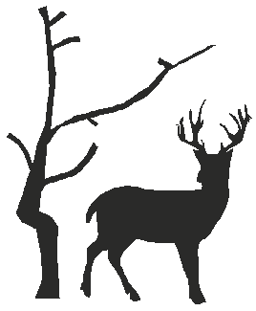
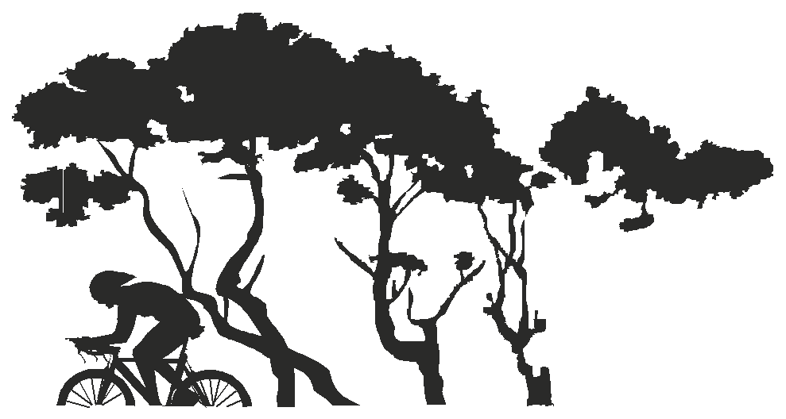

PLEASE CONTACT: EVENT SECRETARY Mark Fairhead CLUB WEBSITE www.ccbreckland.info
19 Sawmill Close Wymondham Norfolk NR18 0TJ Tel 01953 600497 or 07772 516713 e-mail markfairhead@btinternet.com

10 miles Time Trial – Results.
Promoted for and on behalf of Cycling Time Trials under their rules and regulations on
Sunday 18th April 2021 - Course B10/19

TIMEKEEPERS

START Don Saunders – C C Breckland

FINISH Heather Saunders, Heidi Davis C C Breckland

OBSERVER Sally Withey - Swift Racing.

MARSHALLS Carbrooke Roundabout – Phil Hollingsworth EACC, Bruce Williams North Norfolk Wheelers.

Pedestrian crossing – Debbie Cross and Ellen Newstead C C Breckland

Carbrooke/Broadmoor Crossroads – Mick Wood, Roger Sayer, C C Breckland.

SIGNING ON TABLE – Paul Cross

REFRESHMENTS - Simply Just Coffee.

Firstly, a massive thanks to everyone who took part in making this event happen and for turning out to ride – and thank you for sticking to Covid 19 restrictions and respecting social distancing measures.

.
Prizes - One Rider: one prize.

Mens
1st Zachery – AeroLab Ward Wheelz 20:27 £30
2nd Lloyd Chapman – Loose Cannon’s Conditioning 20:29 £25
3rd Mark Richards – DAP CC 20:38 £20

Women
1st Hannah O’Brien – Loose Cannon’s Conditioning 23:21 £30
2nd Verity Smith – Loose Cannon’s Conditioning 23:55 £25
3rd Cindy Beynon – Epic Orange Race Team 24:08 £20

VETS on Std: Prizes
1st Nick Partridge – V C Baracchi +4:55 £30 (under one prize per rider)
2nd Dan Blackburn - Epic Orange Race Team +4:54 - £25 (under one prize per rider)
3rd Mike Watson – Lowestoft Wheelers +4:45 - £20 (under one prize per rider)

TEAM: Loose Cannon’s Conditioning - £10 Each – Lloyd, Black & Staines 62:47 this I believe this has set a team course record.

Complete results for the C C Breckland 10 miles TT - held on the 18th April 2021
Position | Bib No. | Name |  | Cat. | Club | A' Time | Vets. +/- | Vet's position
1 | 40 | Zachery | Herrod | Sen. | AeroLab Ward Wheelz | 20:27
2 | 70 | Lloyd | Chapman | Sen. | Loose Cannon's Conditioning | 20:29
3 | 50 | Mark | Richards | Sen. | DAP C C | 20:38
4 | 20 | Jordon | Black | Sen. | Loose Cannon's Conditioning | 21:01
5 | 55 | Ben | Beynon | Sen. | Rotor Race Team | 21:02
6 | 30 | Timothy | Torrie | Esp. | TBW23 Stuart Hall Cycling p/b Trainsharp | 21:07
7 | 46 | Robert | Staines | Esp. | Loose Cannon's Conditioning | 21:17
8 | 10 | Nick | Partridge | Vet. | V C Baracchi | 21:22 | +4:55 | 2nd
9 | 45 | Dan | Blackburn | Vet. | Epic Orange Race Team | 21:23 | +4:54 | 3rd
10 | 11 | Jake | Crossley | Jun. | Tofauti Everyone Active | 21:31
11 | 42 | Gary | Freeman | Sen. | Orwell Velo | 22:01
12 | 71 | Ben | Keeley | Sen. | Team Velovelocity | 22:03
13 | 60 | Daniel | Bloy | Vet. | Team Velovelocity | 22:05 | +4:12 | 6th
14 | 21 | Ryan | Gray | C5 | Ride Harder | 22:21
15 | 61 | Paul | Hayward | Vet. | V C Baracchi | 22:25 | +3:47 | 10th
16 | 5 | Mark | Arnold | Vet. | VTTA (East Anglia Group) | 22:32 | +3:59 | 8th
16 | 25 | Thomas | Carroll | Vet. | C C Breckland | 22:32 | +3:30 | 15th
17 | 15 | Mike | Padfield | Vet. | North Norfolk Wheelers | 22:33 | +3:58 | 9th
18 | 31 | Adam | Cross | Sen. | C C Breckland | 22:37
18 | 62 | Mike | Watson | Vet. | Lowestoft Wheelers | 22:37 | +4:45 | 5th
19 | 36 | Mark | Howard | Sen. | Eagel Road Club | 22:51
20 | 7 | Tom | Burgess | Sen. | Velo Schils Interbike RT | 23:01
21 | 39 | Mathew | Shotbolt | Sen. | C C Sudbury | 23:06
21 | 57 | Luke | Lynds | Esp. | Tri-Anglia Triathlon Club | 23:06
22 | 56 | Chris | Crabtree | Sen. | Orwell Velo | 23:08
23 | 19 | Joshua | Aiken | Sen. | Orwell Velo | 23:15
24 | 48 | Hannah | O'Brien | L/Vet. | Loose Cannon's Conditioning | 23:21 | +5:15 | 1st
25 | 51 | Philip | Watkins | Vet. | North Norfolk Wheelers | 23:28 | +4:00 | 7th
26 | 17 | James | Sherwood | Sen. | Orwell Velo | 23:34
27 | 16 | Graham | Denny | Vet. | North Norfolk Wheelers | 23:40 | +3:14 | 16th
28 | 38 | Stephen | Clark | Sen. | Orwell Velo | 23:46
29 | 41 | Gary | Johnson | Vet. | C C Sudbury | 23:47 | +3:35 | 14th
30 | 63 | Verity | Smith | F/Vet. | Loose Cannon's Conditioning | 23:55 | +4:47 | 4th
31 | 12 | Ian | Newby | Vet. | Diss & District C C | 23:59 | +2:55 | 17th
32 | 6 | Stuart | Supple | Vet. | V C Baracchi | 24:07 | +2:20 | 19th
32 | 32 | Nicholas | Webber | Vet. | Hadleigh C C | 24:07 | +3:38 | 13th
33 | 73 | Cindy | Beynon | F/Sen. | Epic Orange Race Team | 24:08
34 | 58 | Jonathan | Adams | Vet. | Tri-Anglia Triathlon Club | 24:28 | +2:17 | 20th
35 | 64 | Sandy | Telfer | Sen. | Norwich A B C | 24:29
36 | 67 | Nigel | Walsh | Vet. | North Norfolk Wheelers | 24:33 | +3:40 | 11th
37 | 26 | Jonny | Hawes | Sen. | Gt. Yarmouth C C | 24:36
38 | 43 | Isabella | Johnson | F/Esp. | Datalynx-Parenesis Cycling | 24:53
38 | 66 | Neil | Stevens | Vet. | Tri Harder | 24:53 | +1:43 | 22nd
39 | 29 | Andrew | Bean | Sen. | Wisbech Wheelers | 25:00
40 | 13 | Simon | Hardy | Vet. | King's Lynn C C | 25:15 | +1:43 | 22nd
41 | 53 | Kevin | Hickman | Vet. | API-Metrow | 25:21 | +2:45 | 18th
42 | 59 | James | Moore | Sen. | V C Baracchi | 25:25
43 | 14 | James | Oxbury | Vet. | Norwich A B C | 25:50 | +0:32 | 25th
44 | 74 | Mark | Fairhead | Vet. | C C Breckland | 25:50 | +1:32 | 24th
44 | 72 | Roger | Sewell | Vet. | Wisbech Wheelers | 25:53 | +3:39 | 12th
45 | 33 | Sophie | Lee | F/Vet. | Newmarket Cycling & Tri Club | 26:18 | +2:13 | 21st
46 | 37 | Brian | Carr | Vet. | Gt. Yarmouth C C | 26:40 | +1:41 | 23rd
47 | 18 | Andrew | Vaughan | Vet. | Bedfordshire Road C C | 26:43 | +0:11 | 26th
48 | 44 | Abbey | Thompson | Juv. | Suffolk Youth Team | 27:28
49 | 23 | Alan | McGuire | Vet. | Ipswich B C | 27:39 | -0:22 | 27th
50 | 8 | David | Young | Sen. | West Suffolk Wheelers | 27:42
51 | 1 | Simon | Atherton | Vet. | C C Breckland | 29:23 | -2:11 | 33rd
52 | 28 | David | Fenn | Vet. | C C Sudbury | 29:44 | -0:35 | 28th
53 | 24 | Sarah | Johnson | F/Vet. | C C Sudbury | 29:53 | -1.01 | 30th
54 | 54 | John | Steed | Vet. | West Suffolk Wheelers | 30:17 | -0:57 | 29th
55 | 3 | Mark | Eastwood | Trike | West Suffolk Wheelers | 31:46 | -1:02 | 31st
56 | 49 | Caroline | Wyke | F/Vet. | C C Sudbury | 35:08 | -4.28 | 32nd
57 | 69 | Diana | Bite | F/Sen. | The Racing Chance Foundation | 35:56 LS
DNSA - Riders: Jeremy Briggs, Robert Day, Carl Mace, Graham Hurst, Sandra Senderski & Keith Dorling.
DNS - Riders: George Wallace, Darren Davis, Dan foster & Oliver Wilkins

